**2)Design and Configuration of Star Topologies using Packet Tracer.**

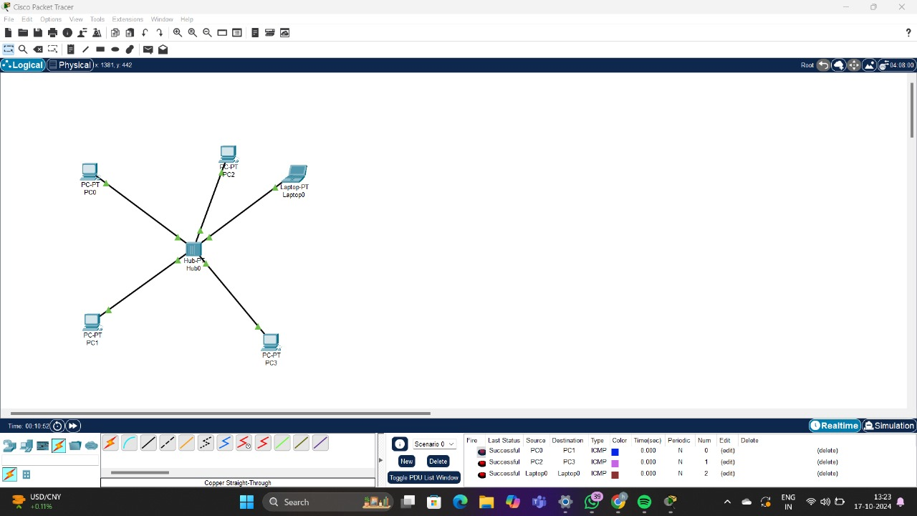

**3)Design and Configuration of BUS Topologies using Packet Tracer.**

.

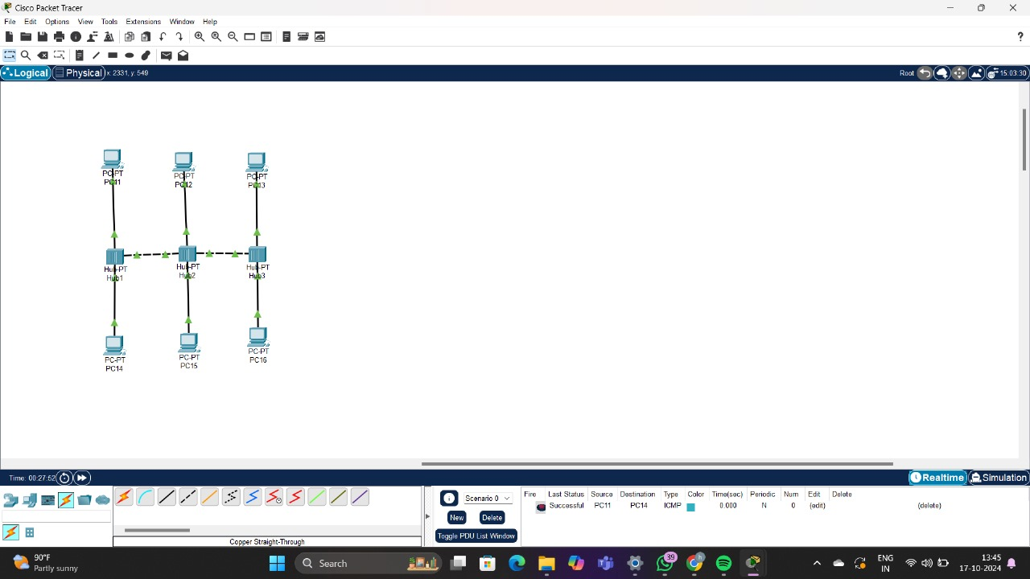

1. **Design and Configuration of Mesh Topologies using Packet Tracer.**

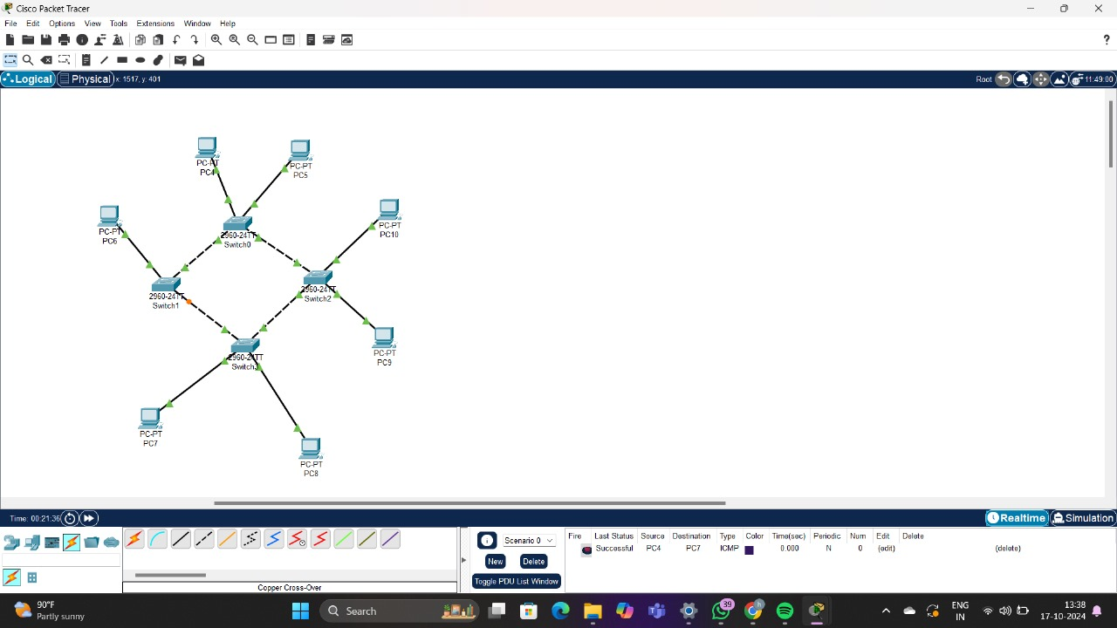

**5)Design and Configuration of Hybrid Topologies using Packet Tracer.**

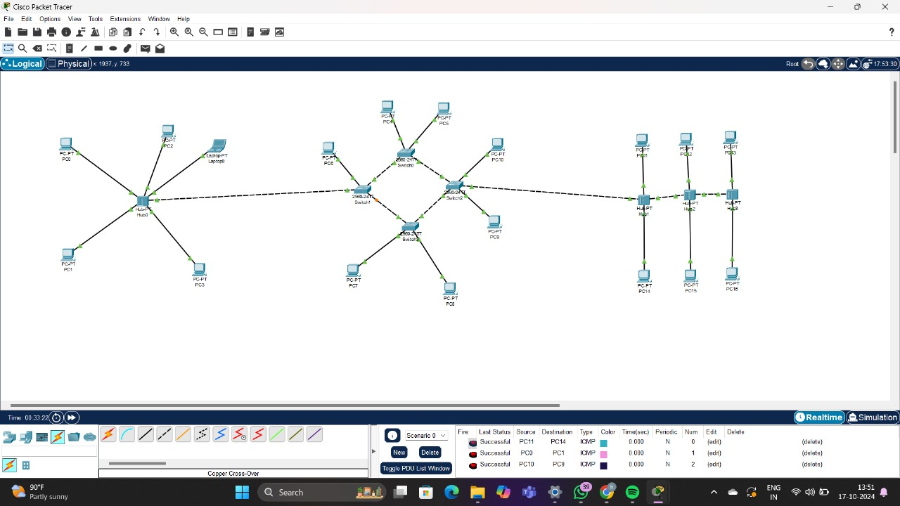

**6)Design and Configuration of Tree Topologies using Packet Tracer.**

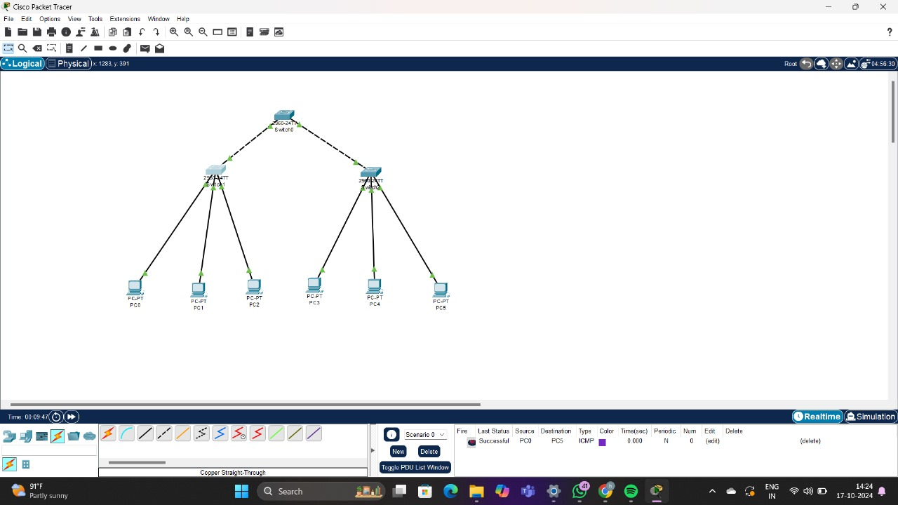

**7)Design and Configuration of RING Topologies using Packet Tracer.**

